**IdeationPhase Define the Problem Statements**

|  |  |
| --- | --- |
| Date | 2 July 2025 |
| TeamID | LTVIP2025TMID50858 |
| Project Name | ToyCraft Tales: Tableau's Vision into Toy Manufacturer Data |
| Maximum Marks | 2 Marks |

Customer Problem Statement Template:

This project helps toy manufacturers and analysts explore data related to toy sales, production trends, and consumer behavior. Using Tableau, the project visualizes insights from historical and demographic data to guide strategic business decisions and respond better to market demands..

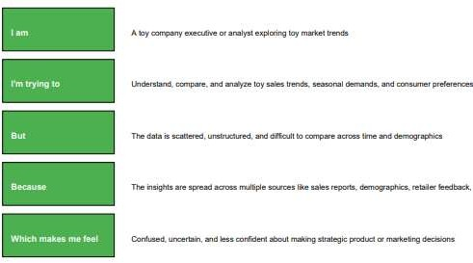

Reference: <https://miro.com/templates/customer-problem-statement/>

**Example:**

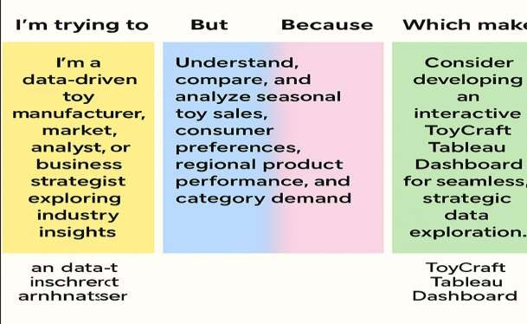

|  |  |  |  |  |  |
| --- | --- | --- | --- | --- | --- |
| **Problem Statement(PS)** | **I am (Customer)** | **I’m trying to** | **But** | **Because** | **Which makes me feel** |
| PS-1 | A toy | Understand toy | Toy sales data | Toy market data | Confused, |
|  | manufacturer | pricing, seasonal | is scattered | is spread across | uncertain, and |
|  | or marketing | trends, regional | across sources | spreadsheets, | hesitant about |
|  | strategist | performance, and | and lacks | reports, blogs, | making informed |
|  | interested in | brand popularity. | consistency. | and retailer | product or |
|  | toy sales and |  |  | dashboards, | inventory |
|  | product |  |  | making it | decisions. |
|  | performance |  |  | difficult to view |  |
|  | trends. |  |  | in one clear |  |
|  |  |  |  | visual. |  |

|  |  |  |  |  |  |
| --- | --- | --- | --- | --- | --- |
| PS-2 | A business | Analyze | Toy industry | There are no | Toy data offers |
|  | student or | market | data is not | regional or | limited insights, |
|  | analyst | share and | presented in | demographic- | making it difficult |
|  | studying | consumer | an interactive | specific | to draw |
|  | toy | preferences | or easy-to- | insights | conclusions from |
|  | industry | across toy | compare | available in a | raw data. |
|  | trends | categories. | format. | visual |  |
|  | and |  |  | dashboard |  |
|  | consumer |  |  | format. |  |
|  | behavior. |  |  |  |  |